**Unique multi-century lake and river ice records provide new insights into changing climate and variability**

**Main text**

Direct annual observations by humans of climatic variables over 5 to 7 centuries are rare. We analyze the longest known contemporary ice records (timing of ice breakup or ice formation) from 1443-2004 for Suwa Lake, Japan and 1692-2013 for Torne River, Finland. These ice records encompass major global events, including the end of the Little Ice Age, a 13-fold increase in human population (United Nations Department of Economic and Social Affairs), substantial land use change, the start of the industrial revolution, and increases in atmospheric CO2 concentrations (IPCC 2013).

The Suwa Lake and Torne River ice records were primarily collected for religious and economic purposes, but provide a unique opportunity to analyze climatic change and variability over centuries (Magnuson et al. 2000). The long-term ice record for Lake Suwa was collected by Shinto priests. The Shinto legend is that, <insert name in English [and in日本語 if you want to be fancy]> the male God would cross the lake to visit the female God at her shrine across the lake once a year. The footsteps of the male God left a sinusoidal ice ridge known as the *omiwatari* in Japanese. The presence of the *omiwatari* was a good omen and a sign of a bountiful harvest in the upcoming year. This important event was celebrated and recorded by at least 15 generations of Shinto priests since 1443 (Arakawa 1954; Benson and Magnuson 2012; Mikami 2008; Takasaki, pers. comm). For Torne River, the tradition of recording the date of ice breakup was linked to the river’s importance in trade, transportation, food, and recreation (Loader et al. 2011).

Using the longest-known direct annual human observations of climate, we asked whether the dates of ice breakup and formation have changed over the past 5-7 centuries in: i) trends, ii) variance, iii) periodicities, and iv) relationships with drivers?

*Increasing trends of warming*

Both Suwa and Torne exhibit increasing trends of warming such that rates of later ice freeze and earlier ice breakup increased significantly in the 1800s in the direction of a warming climate. Second order polynomial models explained 42% of the variation in Suwa and 27% of the variation in Torne ice dates (Figure 1a and b). Torne River froze every year since 1693, but Suwa exhibited an increasing occurrence of no freeze years, such that in the past 50 years, Suwa does not freeze once every four years (Figure 1c). We identified breakpoints, defined as the year in which linear slopes changed significantly, as 1812 for Suwa and 1867 for Torne. The timing of the breakpoints is consistent with the end of the little Ice Age and the start of the Industrial Revolution (Adhikari and Kumon 2001; Mann et al. 2009; Helama et al. 2013). In the region of Japan near Lake Suwa, the Little Ice Age ended in the early 1840s following a cool phase of the Little Ice Age that spanned the late 1820s to early 1840s (Hirano and Mikami 2008; Mikami 2008). Spring air temperatures began rising in the 1880s in the region of Finland near Tornio River, which approximately coincides with the 1867 breakpoint (Helama et al. 2013). In fact, air temperature was the most important predictor of breakup in River Tornio and the second most important predictor of ice freeze in Lake Suwa following the start of the Industrial Revolution. This is consistent with lakes and rivers around the Northern Hemisphere, including in Finland, Sweden, and Japan, that have found strong relationships between air temperature and ice freeze and breakup, such that years with elevated air temperature have correspondingly shorter duration of ice cover (Palecki and Berry 1986; Assel and Robertson 1995; Vavrus et al. 1996; Livingstone 2000; Korhonen 2006; Mikami 2008; Ghanbari et al. 2009; Benson et al. 2012; Helama et al. 2013; Sharma et al. 2013).

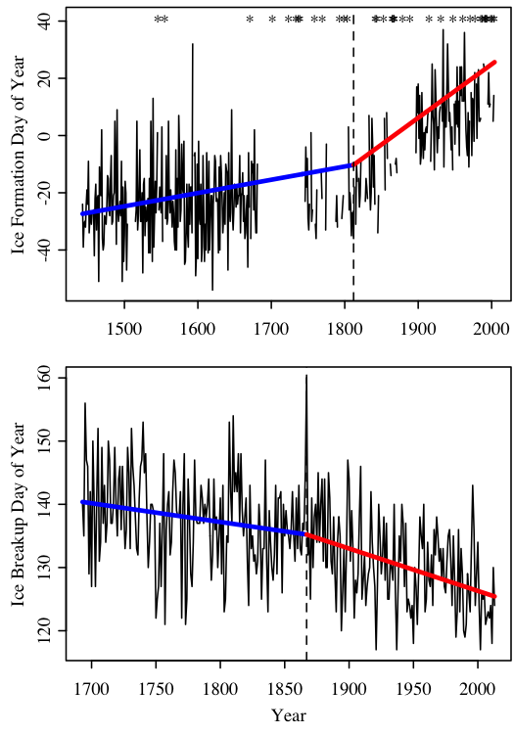

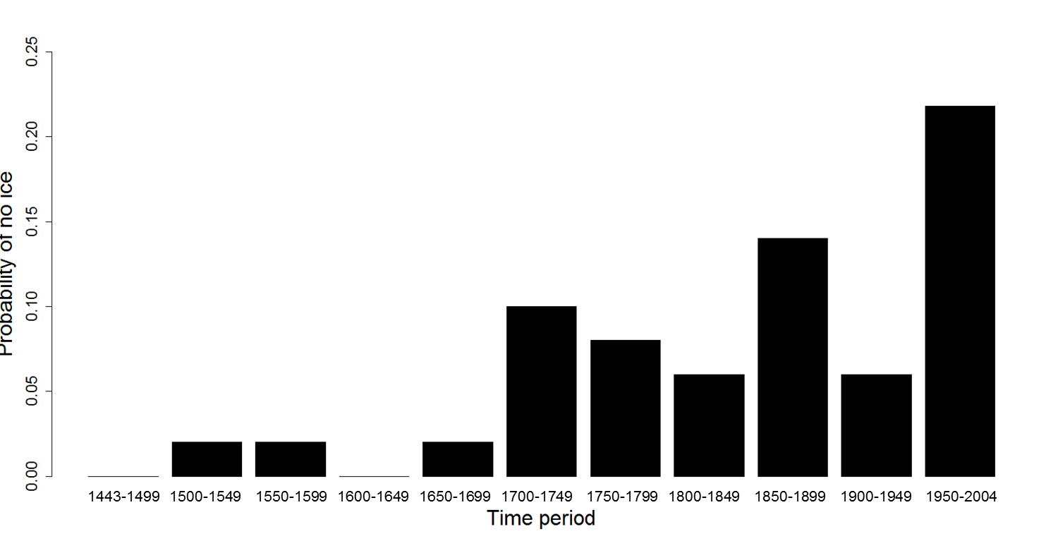

**Figure 1. (A)** Ice formation date in Lake Suwa from 1443-2004, (**B)** Ice breakup date of River Torne from 1693-2012. Blue and red lines indicate linear time trends in ice cover before and after breakpoints. No-freeze years in Lake Suwa (indicated by asterisks) constitute a censored measure of conditions affecting freeze date, and breakpoints and trends were fit using a Tobit regression model. **(C)** Probability of no ice on Lake Suwa for each 50 year period from 1443-2004.

*Decreasing variance*

Generally, variance decreases in the timing of ice formation in Suwa and ice breakup in Torne over 5-7 centuries (Figure 2c and f). The variance in ice breakup date in Torne has been decreasing since 1693 with the lowest variance in the past 50 years (Figure 2 c). For Suwa, variance in ice formation date increased from 1450-1550, decreased from 1550-1650, and decreased from 1950-2000 (Figure 2f). Recently, a number of studies conducted at a temporal scale of a few decades have suggested that inter-annual climatic variability is increasing with increases in greenhouse gas emissions (e.g., ). Karl (1995), however, noted that variance in climate decreases with a longer temporal record, for example the variance in precipitation decreased over a 90-year record. The direct, human-recorded observations from Suwa and Torne reveal a general trend of decreasing variance over 5-7 centuries, although there is variation in variance over short periods of time. Decreasing variance in the ice record reveals the prevalence towards increased occurrences of traditionally considered “extreme values”. For example, Suwa did not freeze only 3 times in a 255 year period (1444-1699), yet recently Suwa did not freeze 12 times in the past 55 years (1950-2004; Figure 1c).

**Figure 2. CAPTION?**

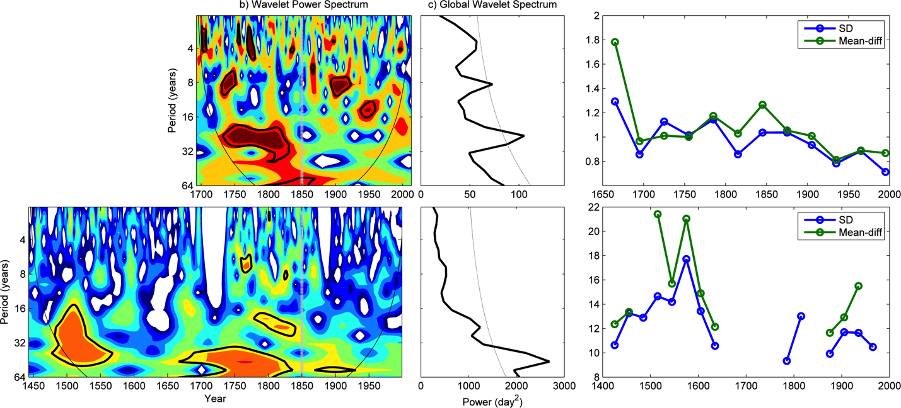

*Changing periodicities*

The power associated with periodicities of different years has changed in both Suwa and Torne following the start of the Industrial Revolution. For example, prior to 1850, periodicities between 3-4 years, 7-12 years, and 20-32 years were significant in the ice breakup dates of Torne River. Following 1850, only periodicities between 8-16 years were significantly apparent (Figure 2a). Similarly for Suwa, periodicities of 16-64 years exhibited significant power in ice formation dates prior to 1850. After 1850, there were no significant periodicities for Suwa (Figure 2d). This change in significant periodicities may suggest a structural change in teleconections among large-scale climate drivers in a warming climate, including ENSO, NAO, and the solar sunspot cycle since the beginning of the Industrial Revolution (Robertson et al. 1992; Christensen and Lassen 1991; Hurrell and van Loon 1997; Higuchi et al. 1999). For example, it appears that there has been a shift in importance of inter-annual cycles of the NAO and increasing CO2 concentrations may have stabilized the positive phase of the NAO (Yoo and D’Odorico 2002). In the latter half of the 20th century, the 6-to-10 year period became more influential and explained more variance in the NAO index, whereas the contribution from inter-decadal periods was almost absent from 1940 to the 1970s (Hurrell and van Loon 1997; Higuchi et al. 1999) In addition, the average length of the sunspot cycle has been identified as approximately an 11-year cycle since 1700 (Christensen and Lassen 1991; Lee et al. 1995). However, as greenhouse gas emissions have increased in the latter half of the 20th century, there has been greater variation in solar sunspot cycle length (Christensen and Lassen 1991).

*Drivers are changing over time*

The relative importance and significance of drivers has changed over time after the start of the Industrial Revolution. For Suwa, a Tobit model suggested that ENSO was the most important driver of lake ice formation before 1850 and carbon dioxide concentrations was the most important driver after 1850. The importance of air temperatures, aerosol optical depth, and carbon dioxide concentrations increased in explaining later ice formation, whereas the role of ENSO decreased (Figure 3a). For Tornio, higher air temperatures, solar radiation, carbon dioxide concentrations, and sunspots suggested that these changing drivers led to earlier ice breakup in Tornio River following the Industrial Revolution (Tobit model; Figure 3b).

**Figure 3. CAPTION?**

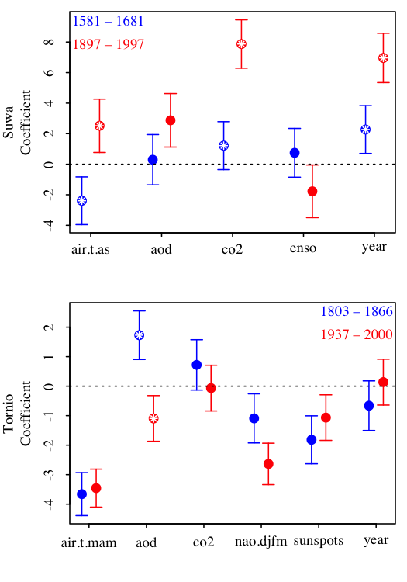

Climate change, atmospheric and large-scale climate drivers, and air temperatures are important interacting drivers of lake ice freeze and river ice breakup. Atmospheric drivers, including solar irradiance and atmospheric CO2 concentrations, were important in explaining ice freeze dates for Lake Suwa and ice breakup for River Tornio. Increased solar radiation input delayed the timing of ice freeze and accelerated the timing of ice breakup (Sharma et al. 2013; Sharma and Magnuson, in review). In particular, the sensitivity to incident solar radiation and solar elevation is higher at the time of ice breakup (Weyhenmeyer et al. 2004; Weyhenmeyer et al. 2011; Benson et al. 2012; Shuter et al. 2013). To our knowledge, this is the first study to document a direct statistical link between increasing atmospheric CO2 concentrations and later ice freeze and earlier ice breakup. The timing of ice breakup may especially be sensitive to CO2 concentrations and warming may be particularly pronounced in winter and early spring at higher latitudes (Yoo and D’Odorico 2002). This suggests the importance of climate change to alterations in ice phenology following the start of the Industrial Revolution and increased greenhouse gas emissions (Crowley 2000; IPCC 2013).

Large-scale climate drivers, including the solar sunpot cycle, ENSO, and NAO were important predictors of freeze date in Lake Suwa and breakup date in River Tornio. Total annual sunspot number, which correlates with the intensity of solar radiation, was an important driver to the timing of ice freeze and breakup. Increased solar radiation input delayed the timing of ice freeze and accelerated the timing of ice breakup (Sharma et al. 2013; Sharma and Magnuson, in review). El Niňo events corresponded to later ice freeze dates on Lake Suwa. ENSO has also been associated with later ice breakup for lakes in North America (Anderson et al. 1996; Livingstone 2000; Robertson et al. 2000; Bonsal et al. 2006), and thinner ice cover (Bai et al. 2012). However, in Wisconsin lakes, the relationship between El Niňo events and later ice breakup appears to be weaker or even switch after 1940 (Livingstone 2000; Robertson et al. 2000). Prior to 1940, cooler air temperatures were evident in late winter of El Niňo years, whereas following 1940 warmer air temperatures were evident in late winter of El Niňo years (Robertson et al. 2000). Lastly, we found an association between ice breakup in River Tornio and the winter NAO index. The winter NAO index has been correlated strongly with ice breakup dates in lakes across the Northern Hemisphere (Livingstone 2000; George et al. 2004; Magnuson et al. 2004; Ghanbari et al. 2009; Karetnikov and Naumenko 2011; Sharma et al. 2013), such that coherent patterns between ice conditions and the NAO index appear to occur inter-annually and inter-decadally (Hurrell and van Loon 1997; Huang et al. 1998; Higuchi et al. 1999; Ghanbari et al. 2009; Sharma et al. 2013). NAO may influence ice breakup dates through its effects on winter air temperature (Blenckner et al. 2007), snowfall (Ghanbari et al. 2009), and alteration in strengths of southerly and westerly winds (Bai et al. 2012).

Air temperatures were the most important predictor of ice breakup in River Tornio and the second most important predictor of ice freeze date in Lake Suwa. Warmer springs exhibited earlier ice breakup date in River Tornio and warmer falls and winters exhibited later freeze dates in Lake Suwa. In Northern Hemisphere lakes, air temperature may be the most important meteorological forcing factor explaining ice conditions (Palecki and Berry 1986; Assel and Robertson 1995; Vavrus et al. 1996; Livingstone 2000; Korhonen 2006; Benson et al. 2012), such that years with elevated air temperatures have correspondingly shorter duration of ice coverage (Benson et al. 2012). Over the past century in Madison, Wisconsin, warming daily and seasonal winter and spring temperatures have been associated with earlier ice breakup and decreases in ice-cover duration (Ghanbari et al. 2009; Sharma et al. 2013). Cooler temperatures even in the month before ice breakup, can delay breakup. Palecki and Barry (1986) observed a strong correlation between ice breakup date and air temperatures five to ten days prior to ice breakup in southern Finnish lakes. Ice breakup and freeze dates may be further delayed in the future as air temperatures are predicted to increase in response to climate change in the coming century (IPCC 2013).

*Conclusions*

Using long-term records, we identify a regime shift in ice freeze and breakup coinciding with the end of the Little Ice Age, the start of the Industrial Revolution, increases in atmospheric CO2 concentrations, and human development (Primack et al. 2009; Loader et al. 2011; Helama et al. 2013). In the past century relative to earlier centuries, we have observed earlier ice breakup, later ice freeze, a doubling to tripling in the rates of change in the timing of ice freeze and breakup, decreased importance of long-term oscillatory dynamics for River Tornio and Lake Suwa, and increased probability of no-freeze years in Lake Suwa.

Our findings in this study and earlier papers (Magnuson 2002; Sharma et al. 2013; Sharma and Magnuson 2014) can be applied to classic problems in science literacy and outreach with regards to climate change. We have used long-term lake ice records because they are easy to visualize, simple to measure without instruments or models, and they integrate many aspects of climate. We highlight the importance of using long-term records to illustrate the influence of a complex array of factors on ice breakup including climate change, atmospheric and large-scale climate drivers, and the vagaries of local weather for freshwater systems in geographically distant regions. Using these long-term ice records we highlight the fallacy of using short-term records to infer progressive climate change or the absence of it when so much variation in ice dynamics is caused by inter-annual and decadal climate drivers and local weather.

**Acknowledgments**

We thank Mayu Takasaki for her translations of Japanese text regarding the legend of omiwatari.

**Methods**

**Data Acquisition**

*Ice freeze and breakup dates*

We obtained ice freeze dates for a 550-year period from 1443-2004 for Lake Suwa and a 321-year record of river ice breakup dates for River Tornio from 1692-2013 from the National Snow and Ice Data Center (NSIDC; Benson and Magnuson 2000). Lake Suwa is a relatively shallow lake (Zmax = 7.2 m) in Nagano Prefecture, Japan where ice-freeze dates have been recorded since 1443. Ice freeze dates occur before and after January 1st, therefore we converted dates to Day-Of-Year (DOY) where a zero value represents the calendar day January 1st. If the lake did not freeze, we used the latest observed ice freeze date for that lake (Benson et al. 2012). Data gaps (e.g., 1682-1736; 1872-1896) were excluded from the time series analyses. Ice breakup dates from River Tornio have been recorded since 1693 and converted to Julian day including considerations for leap years.

*Large-scale climate drivers and weather*

We obtained data from paleo- and historical records that may be important to ice freeze date on Lake Suwa and ice breakup date on River Tornio (Table S1). We acquired average annual sunspot number from 1700-2012 which represents a relative index of solar activity for the visible solar surface from the Solar Influences Data Analysis Center (SIDC-team 2013), volcanic aerosols measured as the annual global average aerosol optical depth inferred at 550 nm from 800-2000 AD derived from sulphate measured in ice cores from Antarctica and Greenland from National Oceanographic and Atmospheric Association (NOAA; Crowley and Unterman 2013), solar irradiance from 9400 BC – 1988 AD acquired from radionuclides extracted from ice cores and tree rings used as a proxy of nuclear reactions with solar activity within the Earth’s atmosphere (Steinhilber *et al.* 2012), and atmospheric carbon dioxide concentrations from 1AD -2012 AD from contemporary atmospheric concentrations from Mauno Loa, Hawaii and splined CO2 records derived from Antarctic ice cores (Keeling et al. 2001). We also acquired an index of El Nino Southern Oscillation (ENSO) from 1301-2005 derived from the North American Drought Atlas (Li et al. 2011) and winter (December-March) North Atlantic Oscillation index from 1659-2013 (Luterbacher et al. 2002; Hurrell et al. 2013).

We acquired local and regional air temperatures for both locations. For the Lake Suwa analysis, we included reconstructed growing season temperatures from Hokkaido, Japan derived from tree ring analysis from 1557-2007 (Davi *et al.* 2001) and local temperatures from Tokyo weather station from 1879-2013 (JMA 2013). For River Tornio, we acquired reconstructed records of monthly temperature adjusted to Haparanda, Sweden from 1802-2002 (nearby town to Tornio; Klingbjer and Moberg 2003). These were updated with monthly records from the Haparanda weather station for 2003-2013 from the International Surface Temperature Initiative (Thorne *et al.* 2011). Reconstructed monthly and annual temperatures for central Europe were obtained for the time series between 1500 and 2007 (Dobrovolný *et al.* 2010). Finally, reconstructed growing season temperatures derived from tree ring analysis from central Sweden were acquired from 1107-2007 (Gunnarson *et al.* 2011; Supplementary Table S1).

**Data Analysis**

*Patterns of ice freeze in Lake Suwa and ice breakup in River Tornio*

To investigate long-term trends in the timing of ice freeze on Lake Suwa and timing of ice breakup on River Tornio, ice freeze and breakup dates were fit using linear, second-order polynomial, and exponential regression models. We selected the best fit model by examining model fit and invoking the principle of Occam’s razor (where parsimony is always favoured). Statistical analysis was conducted using R Software for Statistical computing and the *lm*, *nls*, and *step* functions (R Software 2013).

*Is there evidence of a breakpoint?*

Breakpoint analysis

*Have the same oscillatory dynamics persisted through the time series?*

Spectral analysis

*How have drivers changed over time?*

TOBIT analysis

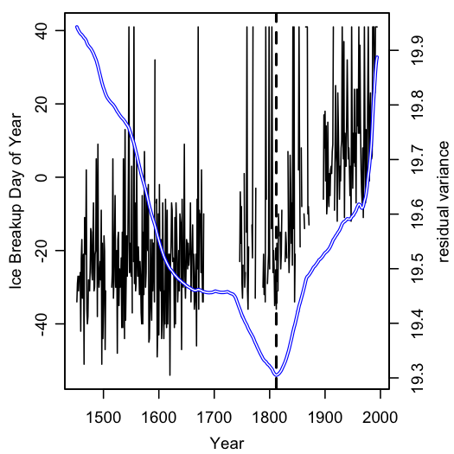

Figure S1. Residual variance from Tobit regression determining breakpoint date for Lake Suwa.

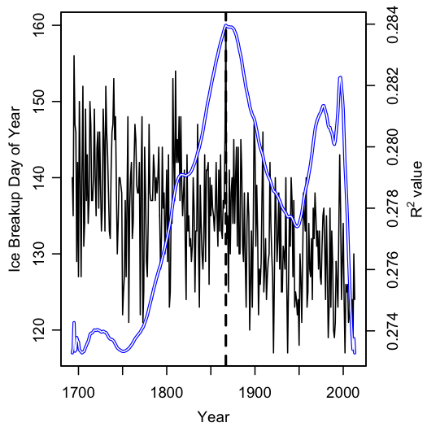

Figure S2. R^2 value from linear regression determining breakpoint date for River Torne.